**GEOL 1010**

**Plate Boundary processes assignment**

Due: Wed 9/12 at midnight

1. Choose a plate boundary to explore
   * 1. (e.g. the boundary between the Australian Plate and the Eurasian Plate – this plate boundary is where these two plates are shown to touch on the plate boundary index map below)

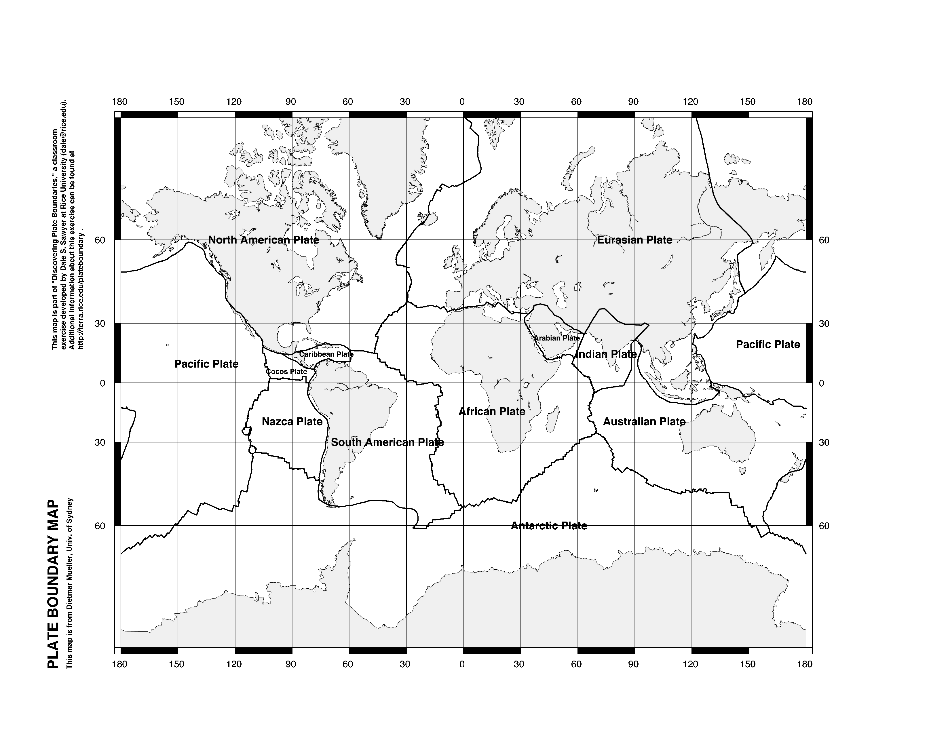

1. Use Google Earth (satellite view) to find this plate boundary. Take a screen-capture of the plate boundary and put in powerpoint (or another program like adobe illustrator if preferred) where you can edit it, add labels, etc.
   * 1. (e.g. the image below of the Australian Plate and the Eurasian Plate boundary)

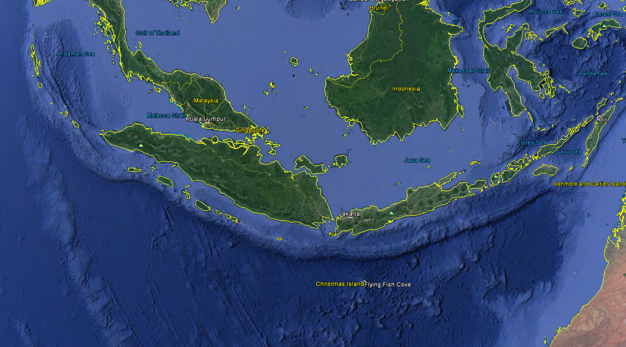

1. Research this plate boundary – what type of boundary is it?
   * 1. (e.g. subduction zone)
2. Knowing what type of plate boundary this is, what features do you expect to see at this boundary when you explore it using Google Earth?
   * 1. (e.g. characteristic topographic features, ocean crust/continental crust, volcanoes, faults/fractures through the crust).
3. Look for such features at your plate boundary and then label them on the screen capture that you took.
4. Write a figure caption (this can go on the second slide) for your annotated screen capture in which you:
   1. Summarize what is happening at this boundary
      1. (e.g. the Australian plate is subducting beneath the Eurasian Plate)
   2. Describe how this has formed the characteristic features you identified and labeled
      1. (e.g. this subduction has formed an oceanic trench off the SW coast of Indonesia as well as a volcanic arc which constitutes some of the Indonesian Islands such as Sumatra and Java. These islands are dotted with large volcanoes. It has also formed an accretionary wedge, most of which is submerged, though in some places it constitutes islands like those of the Mentawi Ridge)
5. Are there any other feature which you expected to see at this boundary that you were not able to identify? What were they? Why do you think you could not identify them? Respond to this prompt on a third slide.

Deliverable: Upload your powerpoint file as a pdf to the Canvas assignment by the due date